**Pemrogramman 4**

**praktikum 5**

**Nama : Muhammad Sidratul Muntaha**

**Npm : 4510210013**

**ScreenShoot**

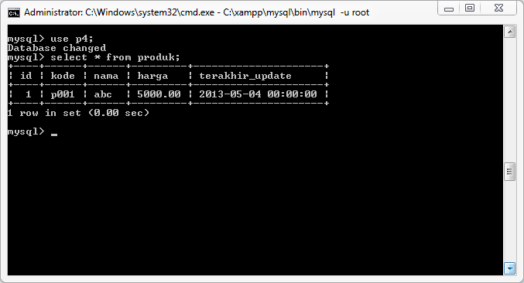

**Gambar 1.** Tabel Produk

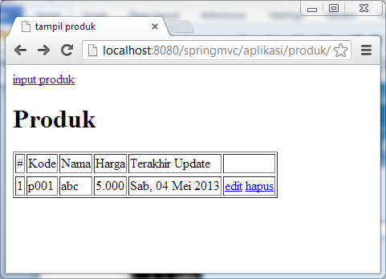

**Gambar 2.** Daftar Produk

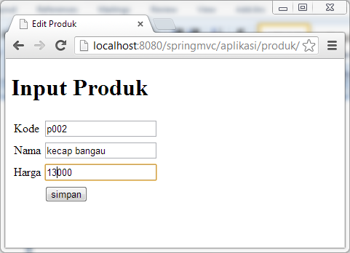

**Gambar 3.** Input Produk

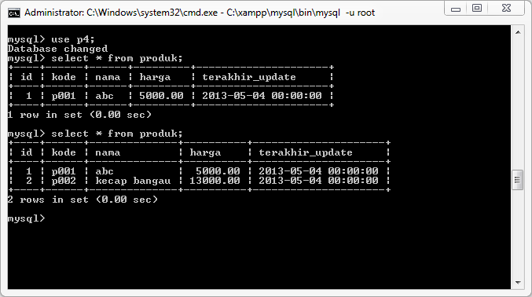

**Gambar 4.** Hasil Input

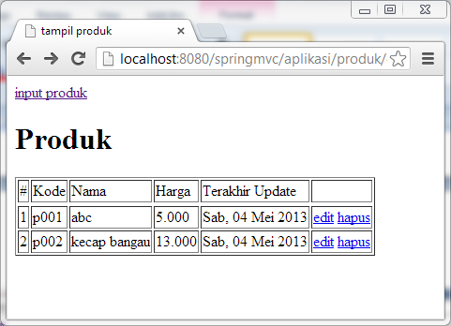

**Gambar 5.** Daftar produk setelah input

**SourceCode**

**Pom.xml**

|  |
| --- |
| <project xmlns="http://maven.apache.org/POM/4.0.0" xmlns:xsi="http://www.w3.org/2001/XMLSchema-instance"  xsi:schemaLocation="http://maven.apache.org/POM/4.0.0 http://maven.apache.org/maven-v4_0_0.xsd">  <modelVersion>4.0.0</modelVersion>  <groupId>com.p4.springmvc</groupId>  <artifactId>springmvc</artifactId>  <packaging>war</packaging>  <version>1.0-SNAPSHOT</version>  <name>springmvc Maven Webapp</name>  <url>http://maven.apache.org</url>  <dependencies>  <dependency>  <groupId>junit</groupId>  <artifactId>junit</artifactId>  <version>3.8.1</version>  <scope>test</scope>  </dependency>  <dependency>  <groupId>javax.servlet</groupId>  <artifactId>javax.servlet-api</artifactId>  <version>3.0.1</version>  <scope>provided</scope>  </dependency>  <dependency>  <groupId>javax.servlet</groupId>  <artifactId>jstl</artifactId>  <version>1.2</version>  </dependency>  <dependency>  <groupId>org.springframework</groupId>  <artifactId>spring-webmvc</artifactId>  <version>3.2.2.RELEASE</version>  </dependency>    <dependency>  <groupId>mysql</groupId>  <artifactId>mysql-connector-java</artifactId>  <version>5.1.23</version>  </dependency>  <dependency>  <groupId>commons-dbcp</groupId>  <artifactId>commons-dbcp</artifactId>  <version>1.4</version>  </dependency>  <dependency>  <groupId>org.springframework</groupId>  <artifactId>spring-jdbc</artifactId>  <version>3.2.1.RELEASE</version>  </dependency>  <dependency>  <groupId>org.springframework</groupId>  <artifactId>spring-context</artifactId>  <version>3.2.2.RELEASE</version>  </dependency>  </dependencies>  <build>  <finalName>springmvc</finalName>  </build>  </project> |

**Web.xml**

|  |
| --- |
| <?xml version="1.0" encoding="UTF-8"?>  <web-app version="2.5" xmlns="http://java.sun.com/xml/ns/javaee"  xmlns:xsi="http://www.w3.org/2001/XMLSchema-instance"  xsi:schemaLocation="http://java.sun.com/xml/ns/javaee http://java.sun.com/xml/ns/javaee/web-app_2_5.xsd">    <context-param>  <param-name>contextConfigLocation</param-name>  <param-value>  /WEB-INF/config-db-spring.xml  </param-value>  </context-param>    <listener>  <listener-class>org.springframework.web.context.ContextLoaderListener</listener-class>  </listener>    <servlet>  <servlet-name>produk</servlet-name>  <servlet-class>org.springframework.web.servlet.DispatcherServlet</servlet-class>  <load-on-startup>1</load-on-startup>  </servlet>  <servlet-mapping>  <servlet-name>produk</servlet-name>  <url-pattern>/aplikasi/*</url-pattern>  </servlet-mapping>    </web-app> |

**config-db-spring.xml**

|  |
| --- |
| <?xml version="1.0" encoding="UTF-8"?>  <beans xmlns="http://www.springframework.org/schema/beans"  xmlns:xsi="http://www.w3.org/2001/XMLSchema-instance"  xsi:schemaLocation="  http://www.springframework.org/schema/beans  http://www.springframework.org/schema/beans/spring-beans.xsd">  <bean id="dataSource" class="org.apache.commons.dbcp.BasicDataSource">  <property name="driverClassName" value="com.mysql.jdbc.Driver" />  <property name="url" value="jdbc:mysql://localhost/p4" />  <property name="username" value="root" />  <property name="password" value="" />  </bean>  <bean id="produkDao" class="com.p4.springmvc.ProdukDao">  <property name="dataSource" ref="dataSource"/>  </bean>  </beans> |

**produk-servlet.xml**

|  |
| --- |
| <?xml version="1.0" encoding="UTF-8"?>  <beans xmlns="http://www.springframework.org/schema/beans"  xmlns:mvc="http://www.springframework.org/schema/mvc"  xmlns:context="http://www.springframework.org/schema/context"  xmlns:xsi="http://www.w3.org/2001/XMLSchema-instance"  xsi:schemaLocation="  http://www.springframework.org/schema/beans  http://www.springframework.org/schema/beans/spring-beans.xsd  http://www.springframework.org/schema/context  http://www.springframework.org/schema/context/spring-context.xsd  http://www.springframework.org/schema/mvc  http://www.springframework.org/schema/mvc/spring-mvc.xsd">  <context:component-scan base-package="com.p4.springmvc"/>  <mvc:annotation-driven />    <bean id="jspViewResolver" class="org.springframework.web.servlet.view.InternalResourceViewResolver">  <property name="viewClass" value="org.springframework.web.servlet.view.JstlView"/>  <property name="prefix" value="/WEB-INF/templates/jsp/"/>  <property name="suffix" value=".jsp"/>  </bean>  </beans> |

**Produk.java**

|  |
| --- |
| package com.p4.springmvc;  import java.math.BigDecimal;  import java.util.Date;  public class Produk {  private Integer id;  private String kode;  private String nama;  private BigDecimal harga;  private Date terakhirUpdate;  public BigDecimal getHarga() {  return harga;  }  public void setHarga(BigDecimal harga) {  this.harga = harga;  }  public Integer getId() {  return id;  }  public void setId(Integer id) {  this.id = id;  }  public String getKode() {  return kode;  }  public void setKode(String kode) {  this.kode = kode;  }  public String getNama() {  return nama;  }  public void setNama(String nama) {  this.nama = nama;  }  public Date getTerakhirUpdate() {  return terakhirUpdate;  }  public void setTerakhirUpdate(Date terakhirUpdate) {  this.terakhirUpdate = terakhirUpdate;  }  } |

ProdukDao.java

|  |
| --- |
| package com.p4.springmvc;  import java.math.BigDecimal;  import java.sql.PreparedStatement;  import java.sql.ResultSet;  import java.util.ArrayList;  import java.util.List;  import javax.sql.DataSource;  public class ProdukDao {  private DataSource dataSource;  private PreparedStatement psInsert;  private PreparedStatement psUpdate;  private PreparedStatement psTampil;    public void setDataSource(DataSource dataSource) throws Exception {  this.dataSource = dataSource;    String sqlInsert = "INSERT INTO `produk`(`kode`, `nama`, `harga`, `terakhir_update`) VALUES (?,?,?,?)";  String sqlUpdate = "UPDATE `produk` SET `id`=?,`kode`=?,`nama`=?,`harga`=?,`terakhir_update`=[value-5] WHERE id=?";  String sqlTampil = "SELECT * FROM produk";    psInsert = dataSource.getConnection().prepareStatement(sqlInsert);  psUpdate = dataSource.getConnection().prepareStatement(sqlUpdate);  psTampil = dataSource.getConnection().prepareStatement(sqlTampil);  }    public void simpan(Produk p)throws Exception{  psInsert.setString(1,p.getKode());  psInsert.setString(2,p.getNama());  psInsert.setBigDecimal(3,p.getHarga());  psInsert.setDate(4,new java.sql.Date(p.getTerakhirUpdate().getTime()));    psInsert.executeUpdate();  }    public List<Produk> tampilProduk() throws Exception{  List<Produk> hasil = new ArrayList<Produk>();    ResultSet rs = psTampil.executeQuery();  while(rs.next()){  Produk p = new Produk();  p.setId(rs.getInt("id"));  p.setKode(rs.getString("kode"));  p.setNama(rs.getString("nama"));  p.setHarga(rs.getBigDecimal("harga"));  p.setTerakhirUpdate(rs.getDate("terakhir_update"));  hasil.add(p);  }  return hasil;  }  } |

**ProdukController.java**

|  |
| --- |
| package com.p4.springmvc;  import java.math.BigDecimal;  import java.util.Date;  import java.util.List;  import org.springframework.beans.factory.annotation.Autowired;  import org.springframework.stereotype.Controller;  import org.springframework.ui.ModelMap;  import org.springframework.web.bind.annotation.ModelAttribute;  import org.springframework.web.bind.annotation.RequestMapping;  import org.springframework.web.bind.annotation.RequestMethod;  @Controller  public class ProdukController {    @Autowired private ProdukDao pd;    @RequestMapping("produk/daftar-produk")  public ModelMap daftarProduk() throws Exception{  List<Produk> hasil = pd.tampilProduk();  ModelMap mm = new ModelMap();  mm.addAttribute("daftarProduk", hasil);  return mm;  }    @RequestMapping("produk/input-produk")  public void tampilkanForm(){    }    @RequestMapping(value="produk/proses", method= RequestMethod.POST)  public String prosesForm(@ModelAttribute Produk p) throws Exception{  p.setTerakhirUpdate(new Date());    pd.simpan(p);  return "redirect:input-produk";  }    } |

**DaftarProduk.jsp**

|  |
| --- |
| <%@page contentType="text/html" pageEncoding="windows-1252"%>  <%@taglib prefix="c" uri="http://java.sun.com/jsp/jstl/core" %>  <%@taglib prefix="fmt" uri="http://java.sun.com/jsp/jstl/fmt" %>  <!DOCTYPE html>  <html>  <head>  <meta http-equiv="Content-Type" content="text/html; charset=windows-1252">  <title>tampil produk</title>  </head>  <body>  <a href="input-produk">input produk</a>  <h1>Produk</h1>  <table border="1">  <thead>  <tr>  <td>#</td>  <td>Kode</td>  <td>Nama</td>  <td>Harga</td>  <td>Terakhir Update</td>  <td>&nbsp;</td>  </tr>  </thead>  <tbody>  <c:forEach items="${daftarProduk}" var="p" varStatus="i">  <tr>  <td>${i.count}</td>  <td>${p.kode}</td>  <td>${p.nama}</td>  <td>  <fmt:formatNumber value="${p.harga}" type="number"></fmt:formatNumber>  </td>  <td>  <fmt:formatDate value="${p.terakhirUpdate}" pattern="EEE, dd MMM yyyy"></fmt:formatDate>  </td>  <td>  <a href="input-produk?id=${p.id}">edit</a>  <a href="delete?id=${p.id}">hapus</a>  </td>  </tr>  </c:forEach>  </tbody>  </table>  </body>  </html> |

**input-produk.jsp**

|  |
| --- |
| <%@page contentType="text/html" pageEncoding="windows-1252"%>  <!DOCTYPE html>  <html>  <head>  <meta http-equiv="Content-Type" content="text/html; charset=windows-1252">  <title>Edit Produk</title>  </head>  <body>  <h1>Input Produk</h1>  <form action="proses" method="POST">  <table>  <tbody>  <tr>  <td>Kode</td>  <td>  <input type="text" name="kode"/>  </td>  </tr>  <tr>  <td>Nama</td>  <td>  <input type="text" name="nama"/>  </td>  </tr>  <tr>  <td>Harga</td>  <td>  <input type="text" name="harga"/>  </td>  </tr>  <tr>  <td>&nbsp;</td>  <td>  <input type="submit" value="simpan"/>  </td>  </tr>  </tbody>  </table>  </body>  </html> |